F4P10104 "Corporéité, arts et développement"
cours n° 1, du 17 septembre 2019
Embodiement processes and child development in Arts teaching-learning lessons
_____________________________________________________________
17.09  2019  M 1140 | - Présentations des objectifs du cours, des ateliers et démarches proposées durant le semestre et des modalités d’évaluation.  - Une expérience fondatrice du cours :apprentissages avec et sans engagement corporel (savoirs « désincarnés » vs/ « corporéisés »).

Le corps et sa mise en scène : pratiques sociales et artistiques
Le cas Edward Bernays.
“When a corporation selling bacon wished to boost its turnover, Bernays engaged the necessary expertise of medics who recommended: there must be hearty stuff for a good breakfast. Since that day US-citizens are loading bombs of calories consisting of scrambled eggs and bacon on their plate in the morning”.

A classic example of the great success of Bernays. After the Great War the suffragettes achieved the right to vote for women. Bernays remembers this in the year 1929 when he was asked by George Washington Hill, at that time head of the cigarette company American Tobacco, how to leverage the stagnating sales of the brand Lucky Strike. Bernays engages ten young models for the Easter Parade in New York in 1929. These models shall light their cigarettes in a publicity effective manner in front of the crowd. Of Course “Eddie” Bernays gave notice to all pressmen in advance that there will be an event with photogenic girls. His clerk Bertha Hunt sends a telegram to the public: “For the sake of emancipation of women and to battle against another gender-taboo, I and other young women will ignite a new torch of freedom by smoking cigarettes while promenading along Fifth Avenue.”

“The primary goal of trusts is to sell products with maximum profit rate. Articles which people really need but offer less profit, the trusts like to leave to medium-sized companies or cooperatives. The consumer shall buy what the trusts offer. Because the consumers will not accept this at once, the public relations experts must avoid the method of rational persuasion but instead lead the customers to their decision to buy goods via secret path. They have to combine with the commodities some connotations which don’t have anything to do with the practical value or exchange value of them.
The emancipation of women for instance.
Equating cigarettes with the Torch of Freedom of New York – this is strong stuff indeed. Until then smoking cigarettes by women in public had been looked at as indecorous. But why should anyone relinquish half of mankind as consumers? After this Lucky Strike rose up to the top of the sales”.
Hermann Ploppa (9 juillet 2015)
https://usacontrol.wordpress.com/2015/07/09/edward-bernays-the-father-of-public-relations/
Le cas Andy Warhol.
With his Campbell’s Soup Cans installation at Ferus Gallery, the artist realized the possibility of creating works in series, and the visual effect of serial imagery. He continued making variations on his Soup Cans, stenciling multiple cans within a single canvas and so amplifying the effect of products stacked in a grocery store, an idea that he would later develop in the box sculptures. He also realized that the serial repetition of an image drained it of its meaning, an interesting phenomenon most poignantly presented in his Disasters, in which the constant exposure to their graphic displays of violence numbs the senses.
Joseph D. Ketner II.
https://www.artspace.com/magazine/art_101/book_report/warhol-campbells-soup-marilyn-54134

“When you see a gruesome picture over and over again, it really doesn’t have any effect”.
ANDY WARHOL, ARTNEWS, 1963
(A propos de « Disasters »)
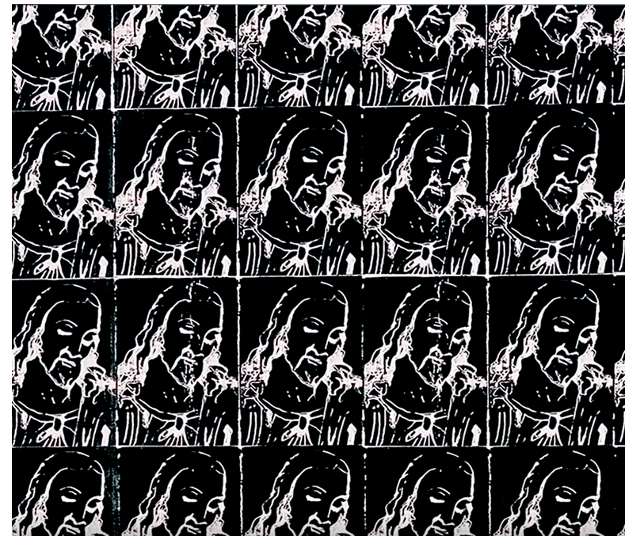

L’œuvre et le mouvement
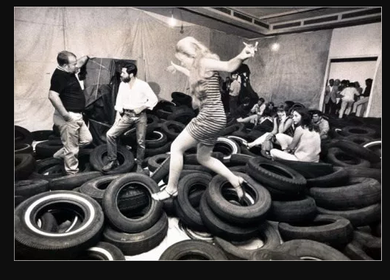
« L’installation interroge de manière critique les typologies classiques des œuvres d’art, elles peuvent être peintures créant une relation avec l’espace et il en va de même pour la sculpture. L’installation peut également questionner les nouveaux médiums comme la vidéo, internet, ou la photographie.
Les frontières entre l’artiste et son public sont parfois remises en cause. »
https://perezartsplastiques.com/2015/11/02/linstallation-dans-lart-contemporain/

Apprentissages avec / sans engagement corporel
Exemple : 25 verbes allemands
lacer (une chaussure) | zubinden
frétiller de la queue (pour un chien) | mit dem Schwanz wedeln
« écumer » (bondir) de colère | vor Wut schäumen
bondir de joie | einen Freudensprung machen
bondir (comme un félin) / sauter à pieds joints / sauter à cloche-pied | hüpfen
s’étirer | sich strecken
pointer | richten
enlacer | umarmen
tapoter | tätscheln
caresser | streicheln
cajoler | liebkosen
se figer | erstarren
souffler (par l’expiration) | blasen
souffler (vent) | wehen
retenir son souffle | den Atem anhalten
s’accroupir | sich ducken
secouer | schütteln
soupirer (physiquement) | seufzen
soupirer (symboliquement) (déplorer quelque chose) | stöhnen
empoigner | ergreifen
visser | schrauben
dévisser | abschrauben
disséquer | sezieren
ramper | kriechen
ramper (pour un petit enfant) | krabbeln

